1. switch role -- account admin -- create account for every one on the team
2. Users & roles -- New user -- create user account
3. Warehouse – Cost management -- resource monitor

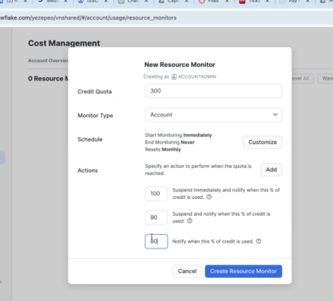

1. How to set time-out warning: project -- worksheet <https://select.dev/posts/snowflake-query-timeouts> alter account set statement_timeout_in_seconds = 86400
2. How to set up snow park: <https://www.udemy.com/share/108Llo3@1m0Y7Zq010Xu12TJgCFkxvnSyogB7-KK2DOWZebqLXJ5i4ik74WSs5MKlKJtiX1e9A==/>
3. Clone data: clone snowflake sql

**TBPAGOS_DOCUMENTOSCOBRO**

1. FechaEmision: invoice date, the date when we start counting the number till the due date
2. CuentaContrato: contract number
3. TipoProducto: T–with the device, I–without the device(but with daily ticket), some cars without ticket and whose license cannot be clearly recorded will be “escaper”
4. ImportePesos: money for transaction
5. Status: 0–transaction unpaid; 9–paid; 8–unpaid, but worth canceling
6. OperacionPrincipal: collection cost
7. FechaCompensacion: day when fee is paid